January 11, 2026
LAw Ching tak (eric)
6583100D
IT8553 Cloud Operations
SysOps‑Driven Cloud Hosting for the Student Records Web Application
Final Project Report
Contents
Executive Summary 2
Introduction 3
Objectives 4
Final Architecture 5
Deliverables 8
Recommendations 10
Glossary 11
Appendix A: CloudFormation Snippets 12
Appendix A: CloudFormation Snippets 13

Executive Summary
Example University’s Student Records Web Application is a mission‑critical system supporting admissions, enrolment, and student management. The legacy hosting environment suffers from performance bottlenecks, outages during peak periods, and limited operational visibility. This project delivers a complete SysOps‑driven modernization of the application by migrating it to AWS and implementing a secure, scalable, and highly available cloud architecture.
The solution uses Infrastructure‑as‑Code (IaC) with CloudFormation, a Golden AMI pipeline for consistent deployments, Amazon RDS Multi‑AZ for database reliability, and CloudWatch for observability. Automated remediation via Lambda ensures self‑healing, while AWS Config, CloudTrail, and Guard Duty strengthen governance and security. Cost optimization is achieved through AWS Budgets, S3 lifecycle policies, and tagging.
The final architecture aligns with the AWS Well‑Architected Framework and provides a robust, maintainable, and cost‑efficient platform capable of supporting the university’s peak academic workloads.

Introduction
Example University’s Student Records Web Application historically experienced:
• Slow performance during peak enrolment
• Outages due to limited scalability
• Manual deployments and configuration drift
• Insufficient monitoring and alerting
• Security gaps and compliance challenges
This project migrates the application to AWS using SysOps best practices, delivering:
• High availability
• Scalability
• Observability
• Security
• Cost efficiency
• Operational automation
The solution is built entirely using CloudFormation, ensuring deterministic, repeatable deployments.

Objectives
- Functional Objectives
- Deploy a fully functional CRUD‑based student records application.
- Ensure low latency and reliable performance.
- Operational Objectives
- Implement a Golden AMI pipeline.
- Deploy a multi‑AZ Auto Scaling Group behind an ALB.
- Migrate the database to Amazon RDS Multi‑AZ.
- Implement CloudWatch dashboards, alarms, and logs.
- Automate remediation using Lambda + EventBridge.
- Security & Governance Objectives
- Enforce encryption, IAM least privilege, and secrets management.
- Enable AWS Config, CloudTrail, and GuardDuty.
- Cost Optimization Objectives
- Use AWS Budgets, tagging, and lifecycle policies.

Final Architecture
- Networking Layer
- VPC (10.0.0.0/16)
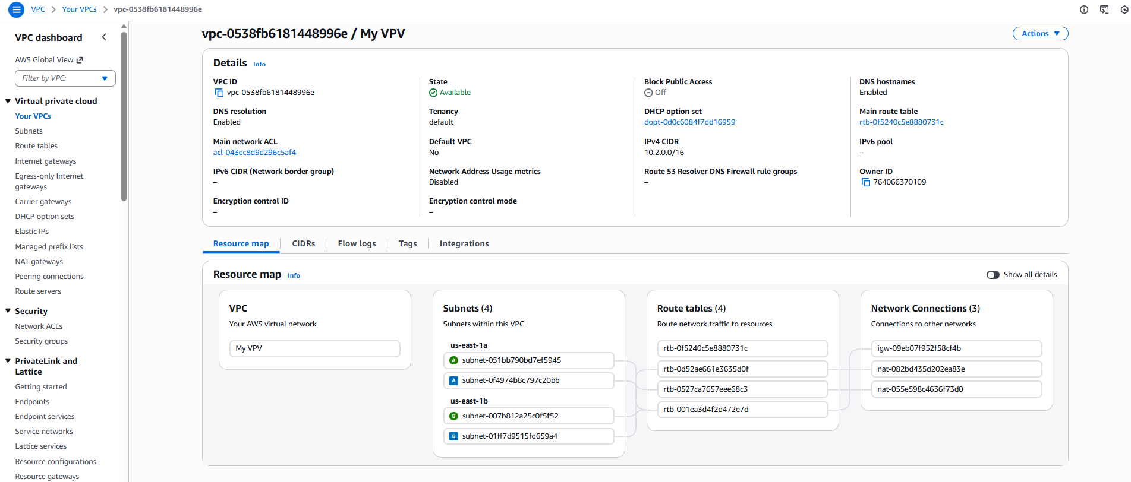
- 2 public + 2 private subnets
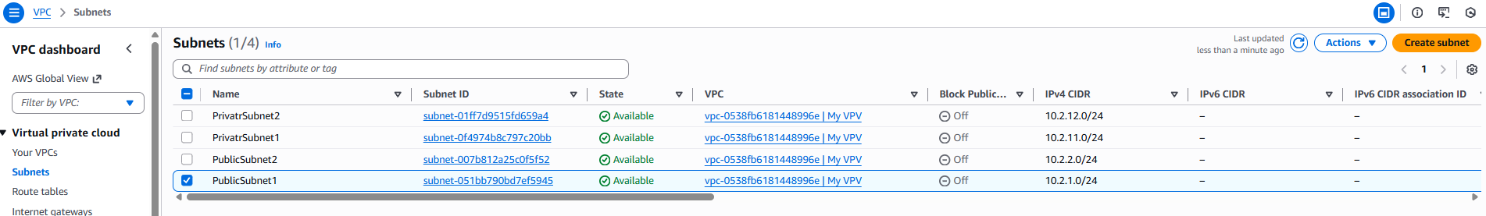
- IGW
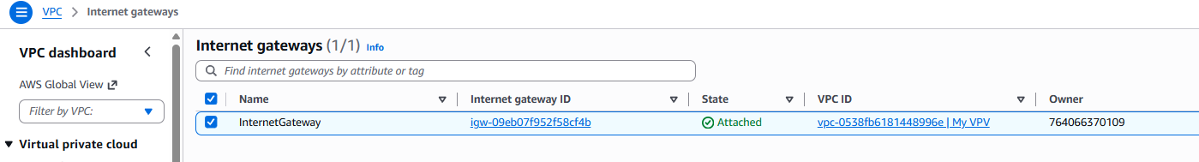
NAT Gateways
- Route tables and associations
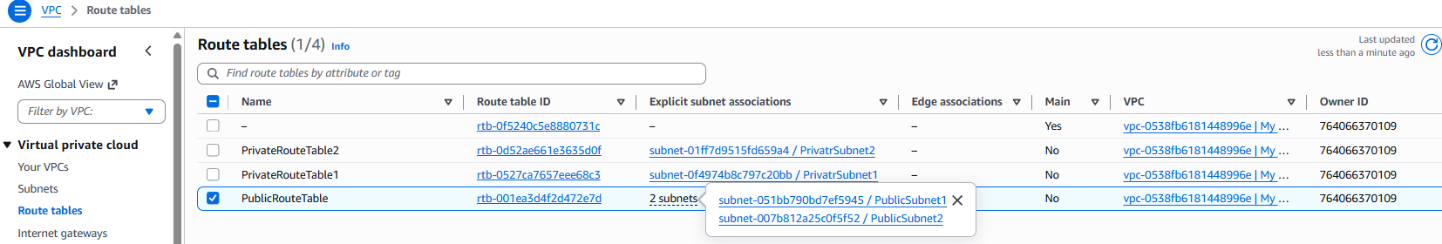

- Compute Layer
- EC2 Auto Scaling Group
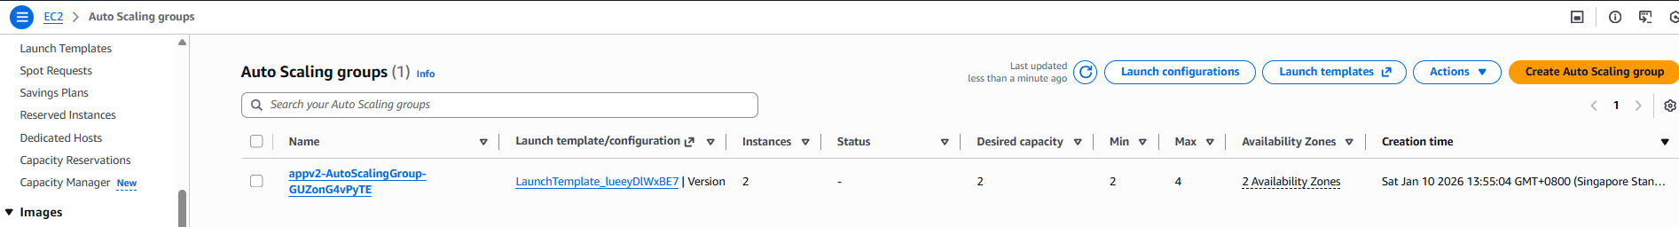

- Launch Template using Golden AMI
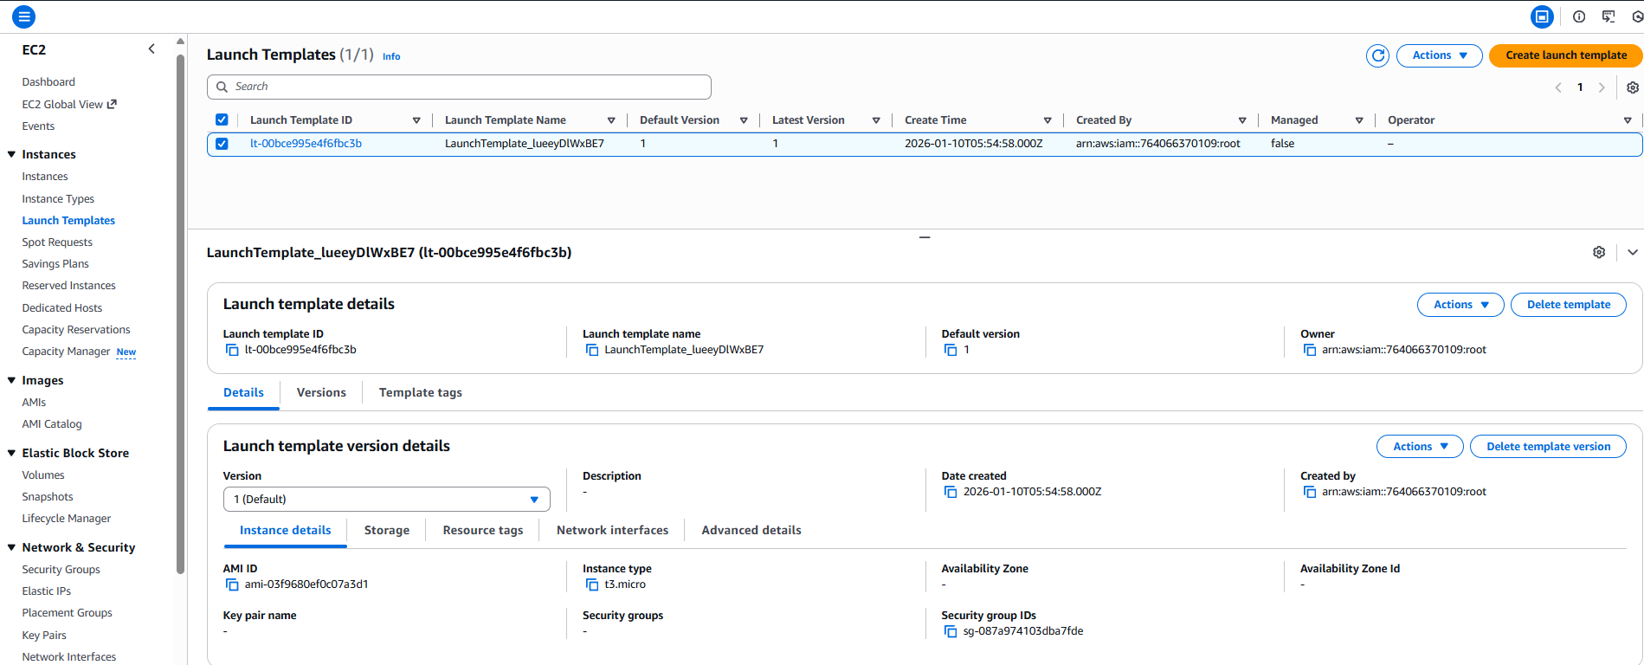
- ALB with health checks
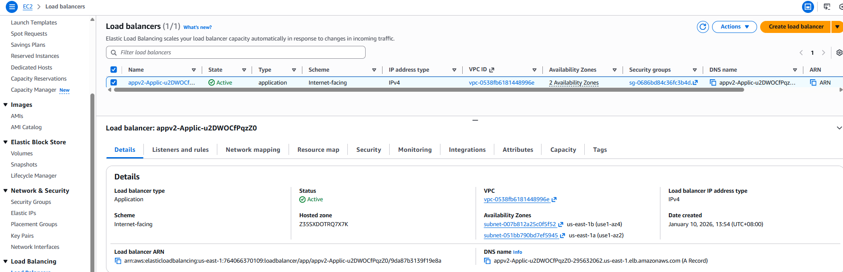
Health checks

- Database Layer
- RDS Multi‑AZ
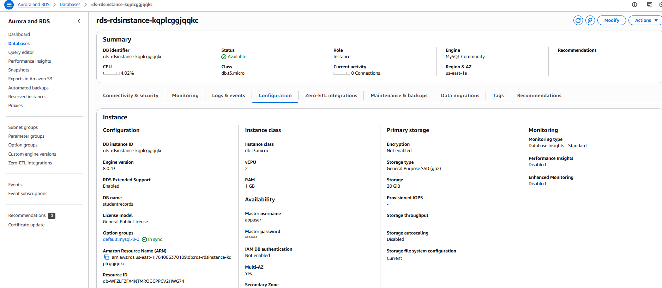
- Private subnets only
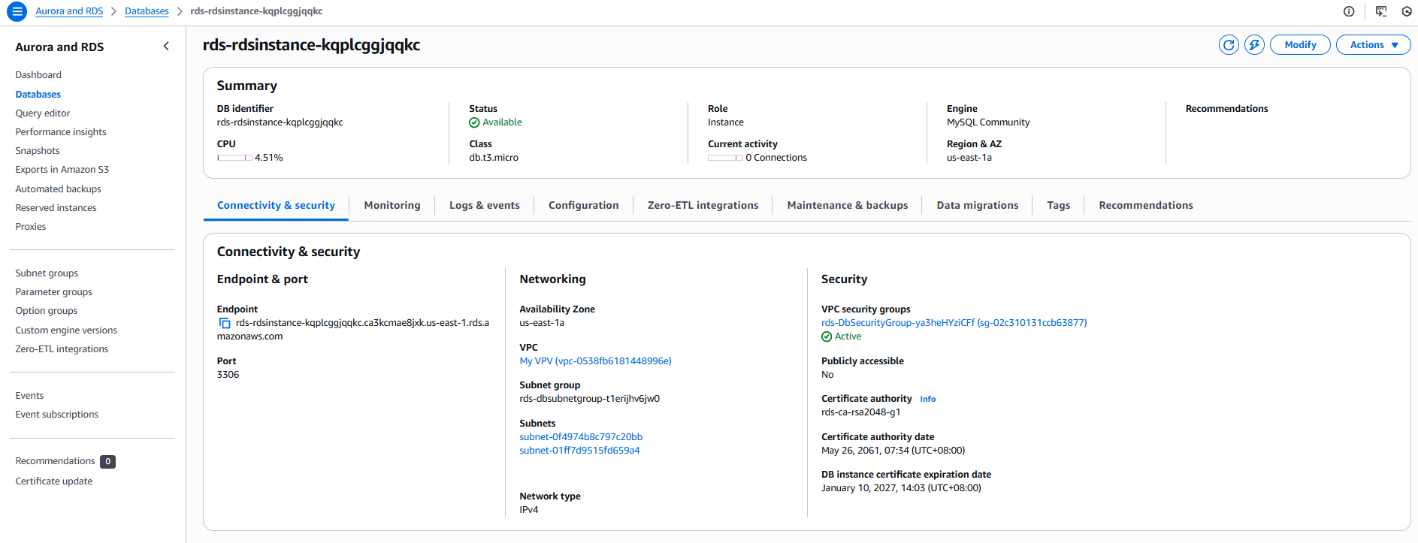
- Secrets Manager for credentials
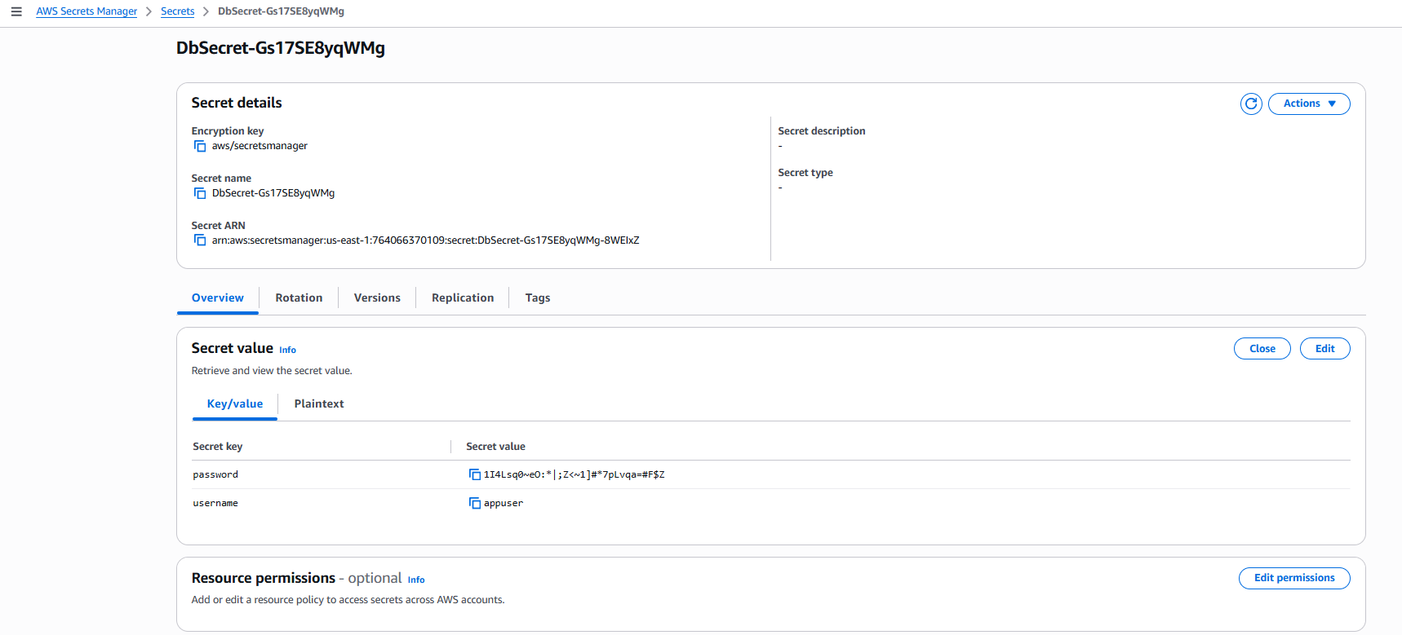

Deliverables
- CloudFormation templates (VPC, App, RDS)
- Architecture diagram
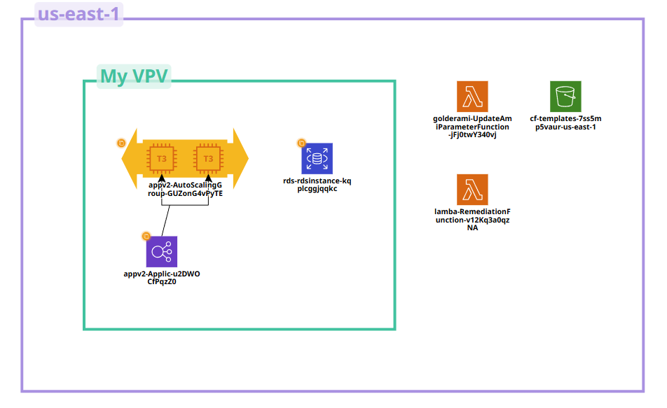

- Cost estimation
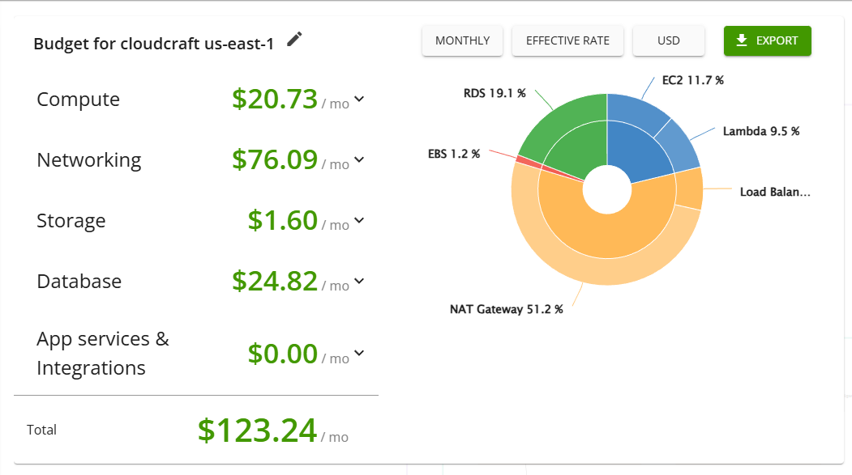

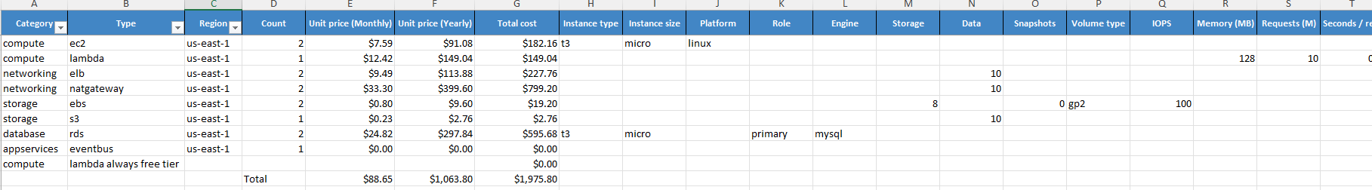
- Well‑Architected Review
Operational Excellence
    - Strengths: IaC, Golden AMI, CI/CD, automation
    - Risks: No runbooks, no chaos testing
    - Recommendations: Add runbooks, implement fault injection

Security
    - Strengths: IAM least privilege, Secrets Manager, encryption
    - Risks: No WAF, no CMKs
    - Recommendations: Add WAF, use customer‑managed KMS keys

Reliability
    - Strengths: Multi‑AZ, ASG, health checks
    - Risks: No cross‑region DR
    - Recommendations: Add cross‑region replicas

Performance Efficiency
    - Strengths: ASG, Golden AMI, RDS
    - Risks: No load testing
    - Recommendations: Add load testing

Cost Optimization
    - Strengths: Budgets, lifecycle policies
    - Risks: NAT Gateway cost
    - Recommendations: Add VPC endpoints

Recommendations
- Enable AWS WAF
Implementing AWS WAF on the Application Load Balancer significantly strengthens the security posture of the Student Records Web Application. WAF provides a programmable, scalable layer of protection against common web exploits such as SQL injection, cross‑site scripting (XSS), HTTP flood attacks, and malicious bot traffic. Given that the application handles sensitive student data, WAF adds an essential layer of defense beyond traditional security groups and IAM controls.
AWS WAF allows the creation of custom rules tailored to the application’s behavior, including rate‑based rules to mitigate brute‑force attempts during peak enrollment periods. Managed rule groups from AWS and third‑party vendors provide immediate protection without requiring deep security expertise. Integrating WAF with AWS Firewall Manager also enables centralized governance and compliance enforcement across environments.
By placing WAF in front of the ALB, the university ensures that only sanitized, validated, and compliant traffic reaches the application layer, reducing the risk of data breaches, service disruptions, and compliance violations.
- Add cross‑region DR

While the current architecture provides high availability within a single AWS region through Multi‑AZ deployments, it does not protect against full‑region outages. Adding a cross‑region disaster recovery strategy ensures continuity of operations even in the unlikely event of a regional failure.
For the database layer, Amazon RDS supports cross‑region read replicas for MySQL and PostgreSQL. These replicas can be promoted to standalone instances during a disaster, providing a near‑real‑time copy of production data. For the application layer, AMIs, S3 assets, and CloudFormation templates can be replicated to a secondary region using S3 Cross‑Region Replication (CRR) and EC2 AMI copy operations.
A Route 53 failover routing policy can automate traffic redirection to the DR region. Infrastructure can be deployed on‑demand using CloudFormation, keeping DR costs low while maintaining rapid recovery capability. This approach aligns with AWS best practices for achieving a Recovery Time Objective (RTO) of minutes and a Recovery Point Objective (RPO) of seconds to minutes.
Implementing cross‑region DR ensures the Student Records Web Application remains resilient against catastrophic failures and meets institutional continuity requirements.

- Implement load testing

Load testing is essential to validate the performance, scalability, and resilience of the deployed architecture. While the Auto Scaling Group and ALB provide elasticity, their behavior under real‑world peak loads must be verified before production use.
Tools such as Locust, JMeter, or k6 can simulate thousands of concurrent users performing CRUD operations. These tests help identify bottlenecks in:
• ALB request handling
• EC2 instance CPU and memory utilization
• RDS query performance
• Application code efficiency
• Scaling thresholds and cooldown periods
Load testing also validates the effectiveness of the Golden AMI by ensuring that instances launch quickly and consistently under scale‑out events. CloudWatch metrics collected during tests provide insights into optimal instance types, scaling policies, and database sizing.
By conducting structured load tests, the university can confidently validate that the system meets performance SLAs during peak enrollment periods and avoids unexpected failures.

- Use VPC endpoints to reduce NAT costs

NAT Gateways are one of the most common sources of unexpected AWS charges, especially when private subnets generate significant outbound traffic to AWS services such as S3, DynamoDB, or Systems Manager. Each gigabyte of traffic through a NAT Gateway incurs data processing fees.
VPC Endpoints (Gateway and Interface types) allow private subnets to access AWS services without traversing the NAT Gateway, eliminating these data processing costs entirely. For this architecture, the most impactful endpoints include:
• S3 Gateway Endpoint — for application assets, logs, and AMI pipeline artifacts
• DynamoDB Gateway Endpoint — if used in future enhancements
• SSM and EC2 Messages Interface Endpoints — for SSM Agent, Patch Manager, and Parameter Store
• Secrets Manager Interface Endpoint — for secure DB credential retrieval
Implementing these endpoints reduces NAT Gateway traffic, improves security by keeping traffic within the AWS network, and can reduce monthly costs by 30–60% depending on workload patterns.

- Add runbooks and patch automation

Operational excellence requires more than automation — it requires clear, repeatable procedures for handling incidents, maintenance, and routine tasks. Runbooks provide step‑by‑step guidance for operators, ensuring consistent responses to common events such as:
• ALB 5XX spikes
• ASG instance replacement
• RDS failover
• Secrets rotation
• High CPU or memory alerts
• Deployment rollbacks
Runbooks reduce human error, accelerate incident resolution, and support onboarding of new team members.
Patch automation further strengthens operational hygiene. Using AWS Systems Manager Patch Manager, EC2 instances can be automatically patched on a schedule using maintenance windows. This ensures that Golden AMIs and running instances remain compliant with security baselines and reduces exposure to vulnerabilities.
Together, runbooks and patch automation elevate the operational maturity of the environment, ensuring long‑term maintainability and compliance.

Glossary
Term | Definition
VPC (Virtual Private Cloud) | A logically isolated section of AWS where you define your own networking environment.
Subnet | A segment of a VPC used to group resources; can be public or private.
Internet Gateway (IGW) | Allows public subnets to access the internet.
NAT Gateway | Enables private subnets to access the internet securely.
EC2 (Elastic Compute Cloud) | Automatically adjusts the number of EC2 instances based on demand.
Launch Template | Defines configuration for EC2 instances in an ASG.
Application Load Balancer (ALB) | Distributes incoming traffic across multiple EC2 instances.
RDS (Relational Database Service) | Managed relational database service supporting MySQL, PostgreSQL, etc.
Multi-AZ | High-availability deployment across two Availability Zones.
Secrets Manager | Securely stores and rotates sensitive information like passwords.
CloudWatch | Monitoring service for logs, metrics, dashboards, and alarms.
CloudTrail | Logs API activity across AWS accounts.
AWS Config | Tracks configuration changes and compliance.
GuardDuty | Threat detection service.
EventBridge | Event bus for automation and scheduling.
Lambda | Serverless compute for automation and remediation.
Image Builder | Automates creation of Golden AMIs.
SSM Parameter Store | Stores configuration values such as AMI IDs.
CloudFormation | Infrastructure‑as‑Code service for deploying AWS resources.

Appendix A: CloudFormation Snippets
- VPC Export Snippet
Outputs:
VpcId:
Value: !Ref Vpc
Export:
Name: !Sub "${AWS::StackName}-VpcId"
PrivateSubnet1Id:
Value: !Ref PrivateSubnet1
Export:
Name: !Sub "${AWS::StackName}-PrivateSubnet1Id"
PrivateSubnet2Id:
Value: !Ref PrivateSubnet2
Export:
Name: !Sub "${AWS::StackName}-PrivateSubnet2Id"

Appendix A: Screenshot Placeholders
- VPC stack
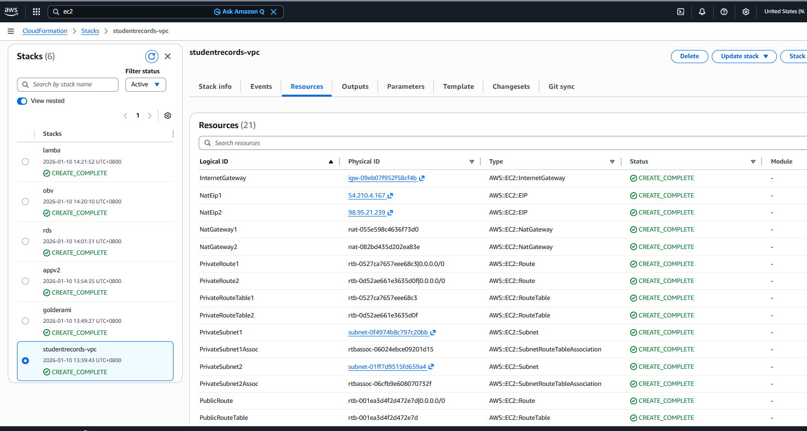

- App stack
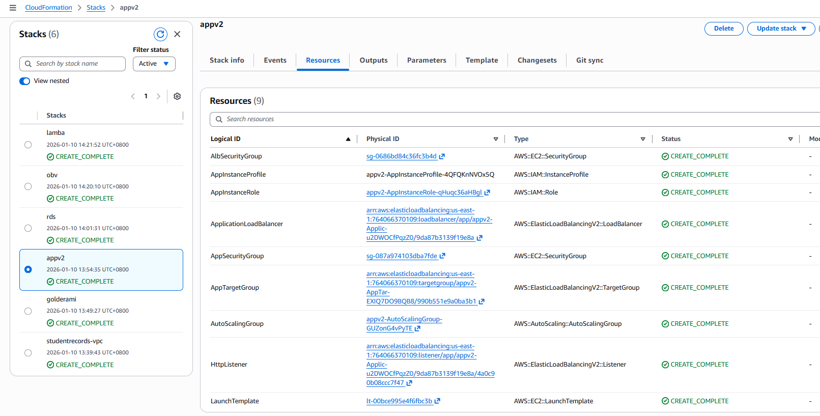

- RDS
